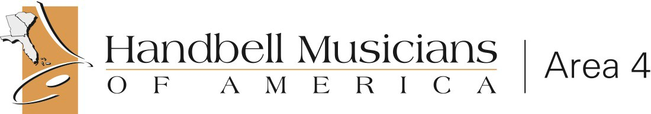
Florida, Georgia, South Carolina, Puerto Rico, The Bahamas and Virgin Islands

